**PROJECT DEVELOPMENT PHASE**

**SPRINT-1**

|  |  |
| --- | --- |
| Team ID | PNT2022TMID33244 |
| Project name | Project- Smart waste management system for metropolitan cities |

**Circuit Diagram:**

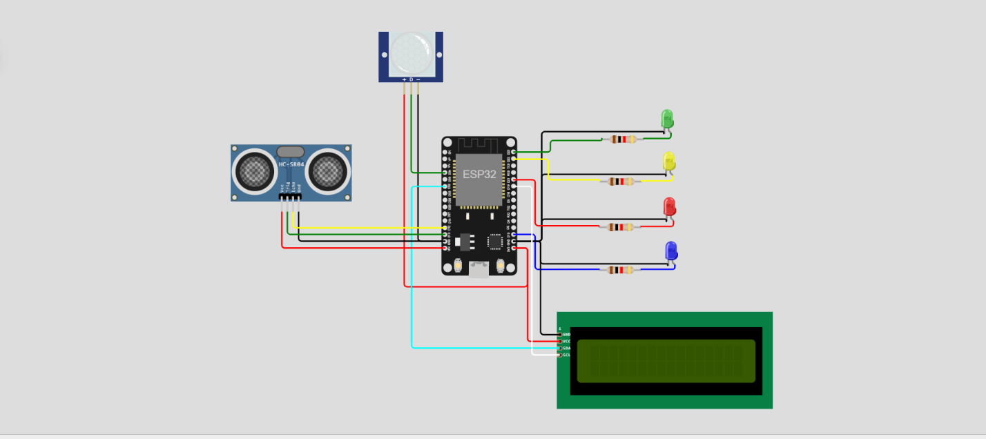

**Simulation with output:**

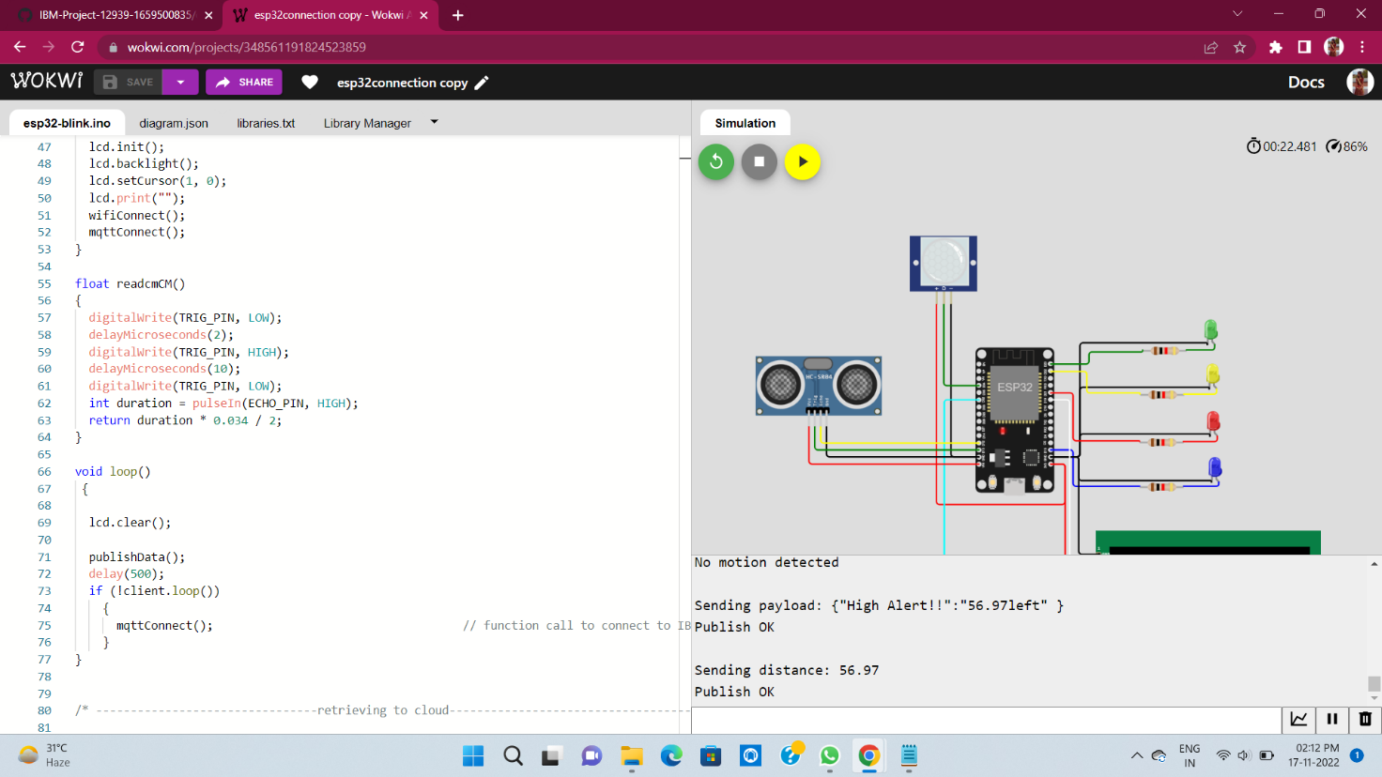

**Simulation connected to IBM Watson :**

